

. ./

**AUTOMOTIVE BUILD PROGRAM Learning Outcome and Mini-project Summary Report**

Prepared by: Shreyashi Sonkar 40020868

Project Approver:

Date of Approval:



**Document History**

|  |  |  |  |  |  |
| --- | --- | --- | --- | --- | --- |
| Ver. Rel. No. | Release Date | Prepared By | Reviewed By | To Be Approved | Remarks/Revision Details |
|  |  |  |  |  |  |

Prepared by : Shreyashi Sonkar

PS Number : 40020868

Contents

Miniproject – 1: Smart trunk Obstacles detetctor 4

Objective 4

Introduction Requirements 5

High Level Requirements 5

Low Level Requirements 5

6

Test Plan 7

High Level Test Plan 8

Low Level Test Plan 9

Implementation and Summery……………………………………………………………………...10

Summary……………………………………………………………………………………..10

Git Inspector Summary………………………………………………………………………10

## List of Figures

Figure 1 Behavior Diagram 6

Figure 2 Structure Diagram 7-8

Figure 3 Git Dashboard 10

Figure 4 Git Inspector Summary 10

Figure 5 Behavior Diagram……………………………………………………………….13-14

Figure 6 Structure Diagram 15-16

Figure 7 Behavior Diagram 20

Figure 8 Structural Diagram 21

Figure 9 Git Dashboard 23

Figure 10 Structure Diagram 25

Figure 11 Simulation Diagram 29

Objective:

Main objective of the project is to reduce the accident caused by closing trunk door automatically. When we use the trunk for storage or to keep our thing in trunk and close, It will not detect the any body part or obstacles that’s why we use sensor to sense the obstacles while closing trunk door and it will lock the door on open mode with the help of servo motor this project use for safety purpose.

Methodology:

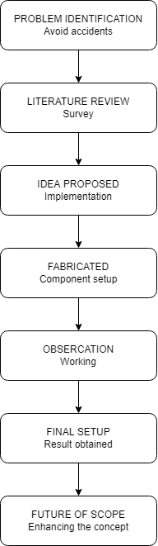

# Introduction:

# SMART TRUNK OBSTACLES DETECTOR: The present time a system and a method for automatically controlling opening/closing of a trunk door of a vehicle, and more particularly, to a technology for user with load in both hands to easily open the trunk door of a vehicle, by mounting a microphone at the rear of the vehicle Such that the trunk door of the vehicle can be opened/closed in response to a sound inputted through the microphone in car when car trunk close automatically, it’s can't detect any obstacles or body part while closing.

# In the current time car trunk are very smart but it have some issue like sometime car trunk is closing it don’t detect any thing or any human body part. This will harm the body part or thing.

# "Smart trunk obstacles detector will detect the any obstacles while closing the trunk door. when we close our trunk door its directly close without any detection sometimes it harms the human body part like our finger or any important thing."

# the trunk door will detect the body part or anything with the help of sensor and it will lock the trunk door means it hold the door on open stage only.

**Requirement:**

High level requirement:

|  |  |  |
| --- | --- | --- |
| ID | DESCRIPTION | STATUS |
| HLR_01 | The door will open when fob is near by the car around 1 meter. |  |
| HLR_02 | When sensor detect the foot kick then door will be open. |  |
| HLR_03 | If sensor will sense any obstacle on the edge of trunk then the trunk door will be locked by servo motor in open mode. |  |
| HLR_04 | The display will show there is any obstacles on the edge of trunk. |  |

Low level requirement:

|  |  |  |
| --- | --- | --- |
| ID | DESCRIPTION | STATUS |
| LLR_01 | The door will open when fob is near by the car around 1 meter. The ECU configured it is in 2 bit.  Fob is near by the car 1 meter = 1 the boot detect sensor will work.  Fob is not around 1 meter of car =0 the boot detect sensor will not work. |  |
| LLR_02 | When sensor will detect the foot kick. The ECU configured it in 2 bit.  Boot Sensor = 1 door will open  Boot Sensor = 0 door will not open |  |
| LLR_03 | If IR sensor will sense any obstacle on the edge of trunk then the trunk door will be locked by servo motor in open mode. The ECU configured it is in 2 bit  IR sensor =1 The door will locked in open mode and send.  IR sensor =0 door will be closed. |  |
| LLR_4 | The display will show there is any obstacles on the edge of trunk. The ECU configured it in is 1 bit. |  |

**Test Plan:**

High Level Test Plan:

|  |  |  |  |  |  |
| --- | --- | --- | --- | --- | --- |
| Test ID | Description | Expected Input | Expected output | Actual o/p | Status |
| HLT_01 | Fob near by car around 1 meter | Fob near the sensor | Boot sensor can work |  |  |
| HLT_02 | When sensor detect the foot kick | Sensor detection | Door will open |  |  |

Low Level test plan:

|  |  |  |  |  |  |
| --- | --- | --- | --- | --- | --- |
| Test ID | Description | Expected input | Expected output | Actual o/p | Status |
| LLT_01 | When the IR sensor will sense any obstacles on the trunk edge | IR=1  IR=0 | Door will be on open mode only.  Door will be closed. |  |  |
| LLT_02 | When IR sensor will detect any obstacles | Obstacles =0  Obstacles =1 | Display “off”  Display will show the “you can’t close the door.” |  |  |

**Behavioral Diagram:**

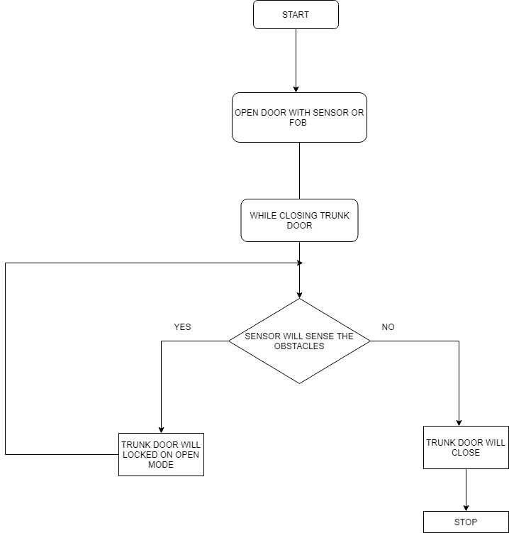

**Structural Diagram:**

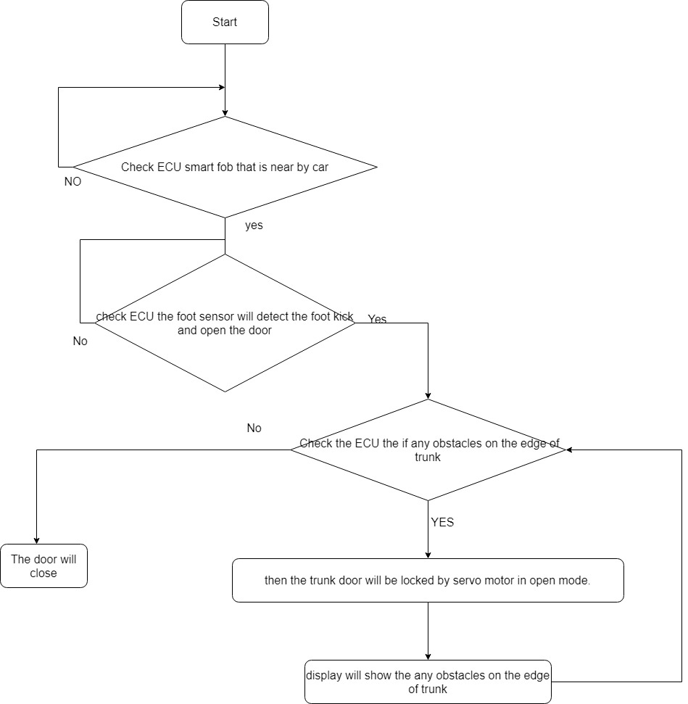

# 

# SWOT Analysis

# Strength:

# This project is use for safety purpose

# Smart Trunk obstacles detector automatically detects the presence of the human body part or any obstacles while closing.

# Weakness

# The weakness of this, sometimes sensor might not be detect the obstacles because of the sensor variation.

# Opportunity:

* They have great accuracy than many other methods at measuring the curve and other objects
* Their high frequency, sensitivity and penetrating power make it easy to detect external or deep objects

**Threats:**

In case its sense any wrong material this time it will not close the trunk.

* Inaccurate readings
* Limited testing distance

**4W’s and 1H**

Who:

In this project the sensor which we can use in any automatic door , hand drawer.

What:

In this project IR sensor will detect the obstacles or body part.

When:

sensors measure the distance to a wide range of objects regardless of shape, color or surface texture. They are also able to measure an approaching or receding object. By using “non-contact” distance can be measured without damage to the object.

Why:

It effective use for the safety.

How:

When door will close, it will detect the obstacles with the help of sensor if any obstacles detect with sensor the trunk door will lock at the open mode.

# Implementation:

CAN (Controller Area Network) protocol is used here to communicate between ECU’s. Here CAN protocol is used because of its many features:

Low Cost. When the CAN protocol was first created, its primary goal was to enable faster communication between electronic devices.

* Built-in Error Detection.
* Robustness.
* Speed.
* Flexibility.

**SIMULATION DIAGRAM:**

